In this lesson we will talk about color channels in natron

We know there are three channels that is red ,blue and green. There is another one that is alpha

Now there is preset in Natron that is colorwheel

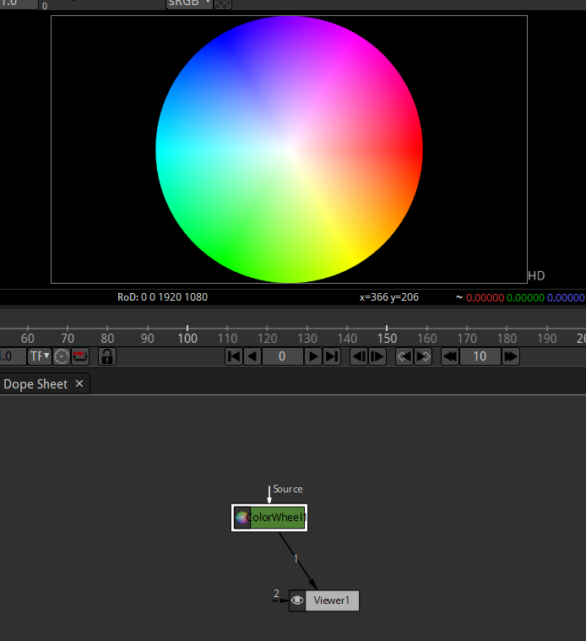

It will look like above

Now if we export it as an image

Then its background will be transparent in nature(if you export in png extension)

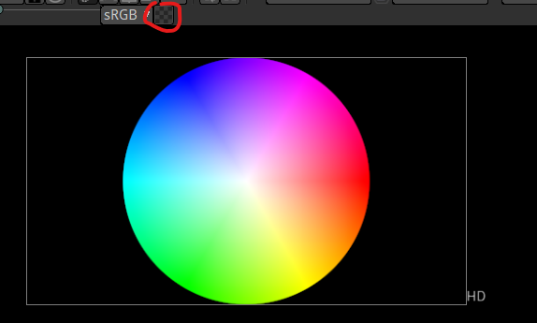

If you want to see transparency as group of blocks rather than black screen then click on above marked then you will see like below

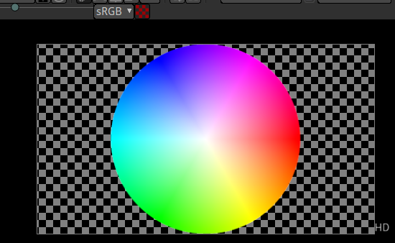

**Note:-**

Different programs renders transparency differently In some software the transparency might be In block or white color or black and white boxes as shown above but just know this is a transparent layer

We are going to look at different channel now

If we change in the shown below

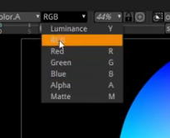

Then that particular color will be highlighted in the viewport 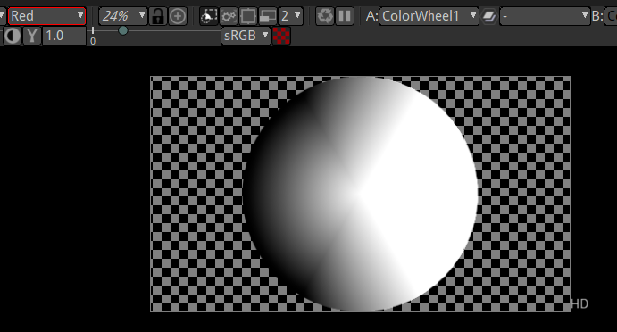

Now if we choose red color then it will be modified as above

The white portion tell that the color you chosen is more prevalent there

Now if we choose green color then it will look like below

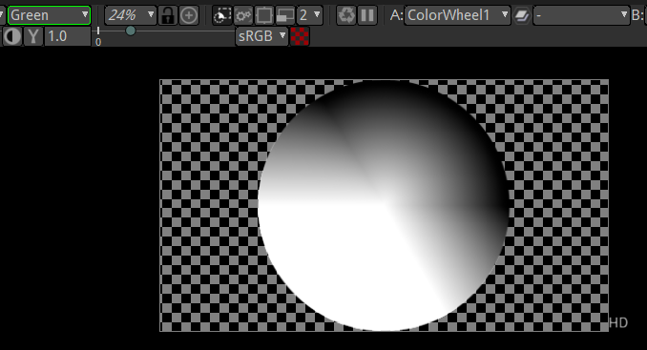

So play with that little bit

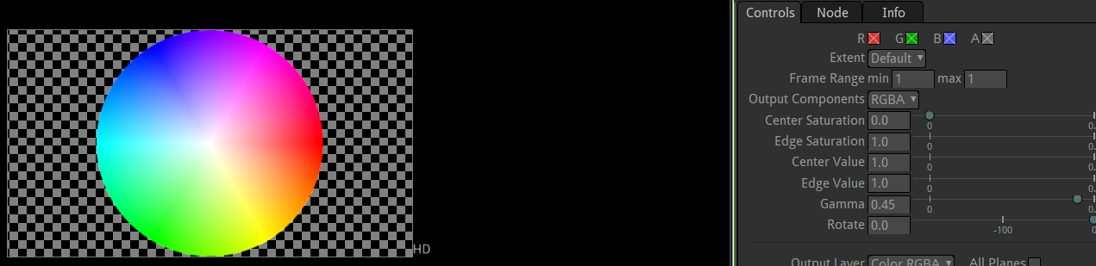

If we go to the properties of wheelcolor we have option for wht part of the color wheel are really being shown in the project

If I uncheck red

then in colorwheel green and blue will be shown

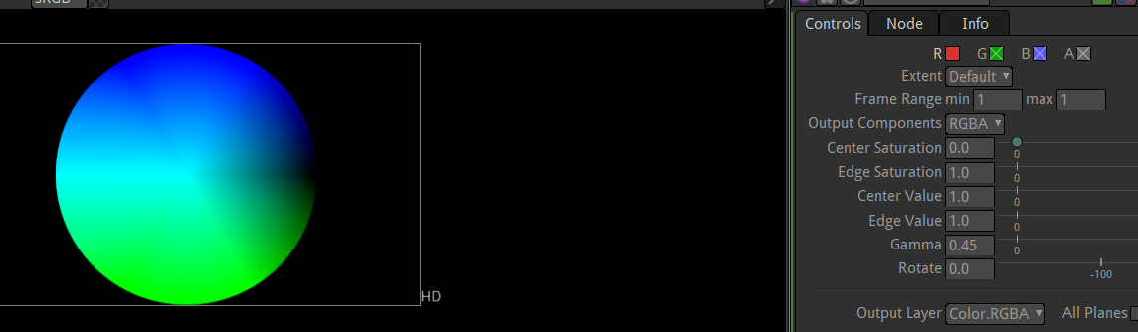

Similarly if we uncheck blue instead of red then red and green will be shown

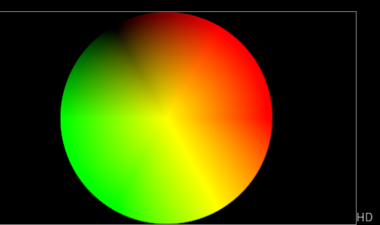

But if you uncheck green and blue

Then it will look like below

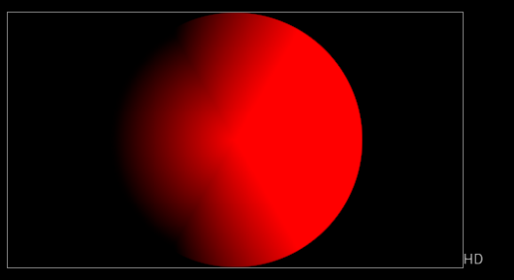

It is similar to when we were seeing the viewport from a red channel but ninstead of white it is red in color

If we make everything normal (means RGB) is checked and see the viewport from red color channel then the out will still be a normal colorwheel

This is because our viewer is only representation to us

What’s really happening is what’s here over there in properties

So it does not matter How you change the viewport

Its example is that if we zoom out and you export then you can assume the out put will be small in size Its not

5:15

This is just the way we are viewing it

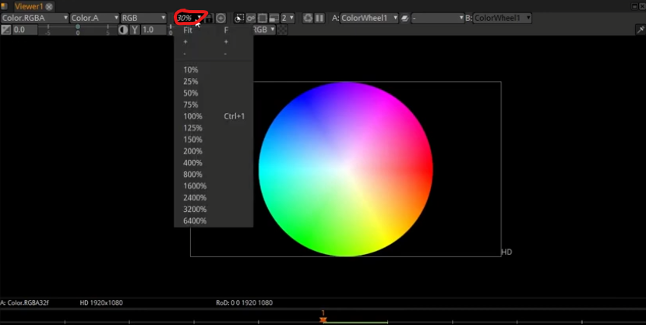

We can click on marked one to show the list and decide zoom level

We can view it for 100 percent and 10 percent

But that’s just how we view it

What size it is going to be render will be decided by project settings

And the colors it renders and exports is determined by which boxes are checked as marked below

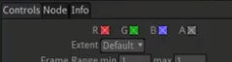

Not by what setting we are viewing it in viewer window

There are other option whose use I can find for now in our viewport

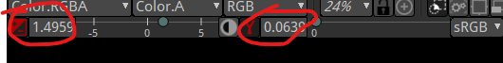

The right marked area I think can increase or deacrese its sharpness of edged

And left marked is for increasing the influence of approx. color in choosing the color boxes

With low right and high left we get this result(learn about later in future)

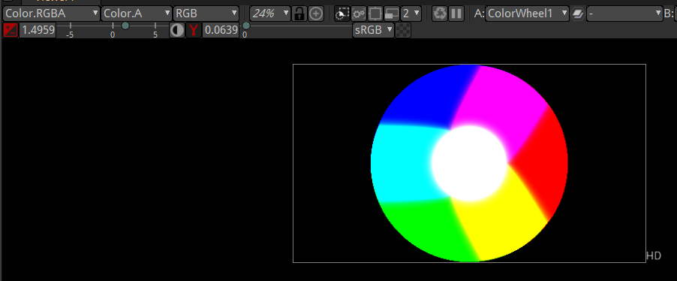

But you cannot achieve it here because it is done in viewer not by properties

We do some experiment

We make a merge node and set its foreground to colorwheel and background for colorbar

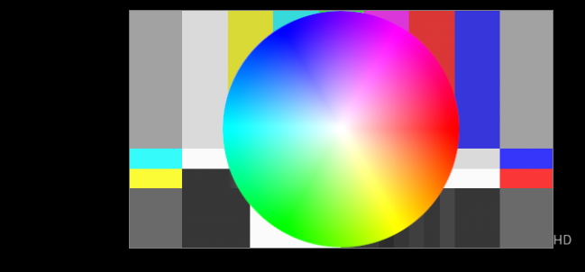

Now we use radial

In place of colorbar

So we will see from the start

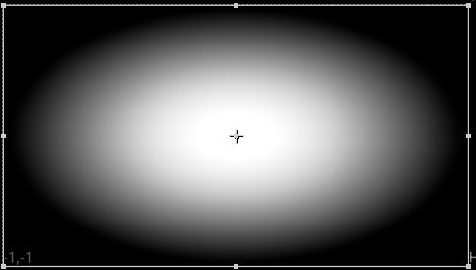

The radial It look like fading out to block but actually it does fade out to transparency(as the alphais set to 0)

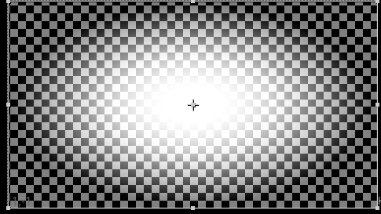

Now we set the color 0 to green now it will look like below

and we also set its alpha to 1

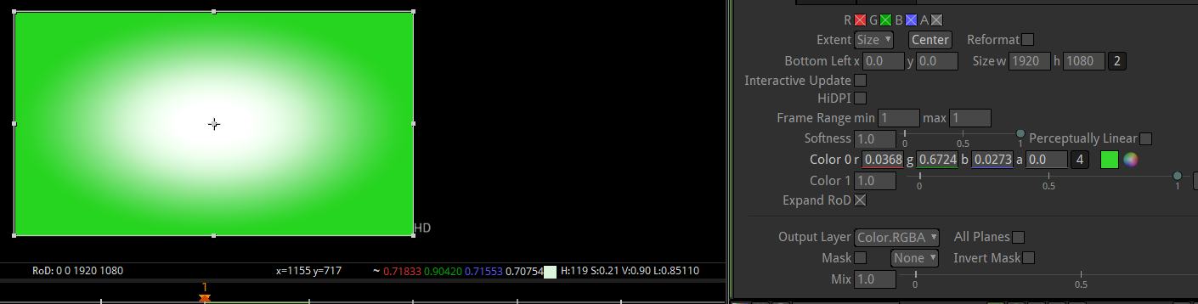

Now it is fading from white to green

but this time we turn on the transparency button no transparency will be shown

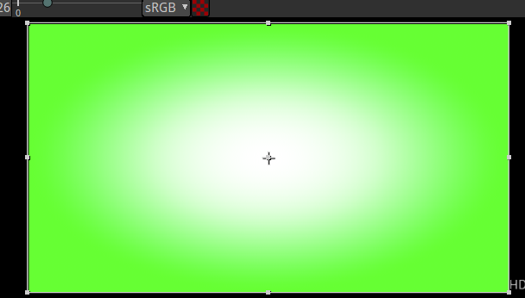

which shows if we are going to render it then we will get as it is

but if we make the alpha of color 0 to 0.5 and then turn on the transparency mode as marked below

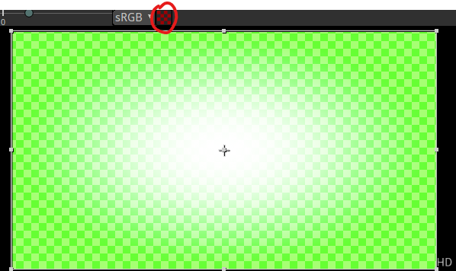So now the color behind it may effect the overall output because there color may pass through thee transparency

Now if we set the colorbar as background then it willbleed through background as shown below

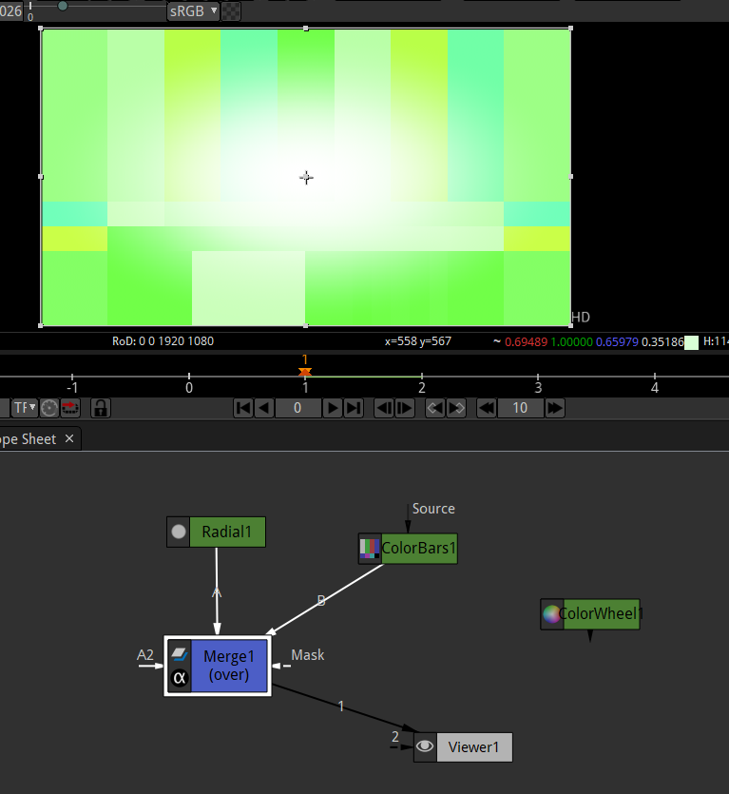

Now it we export it it will look like above as it is to check it we see it in alpha mode on as marked above   
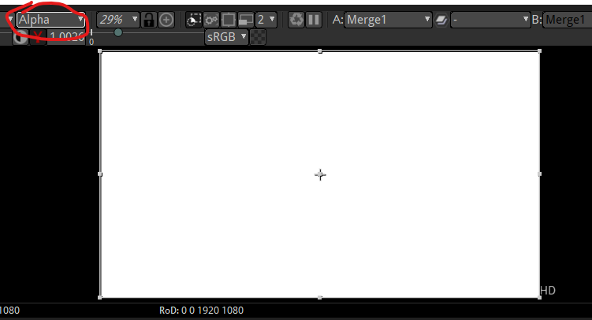

So we are seeing all the pixel at 100 percent strength but if I disable the ColorBars then we see different output as shown below

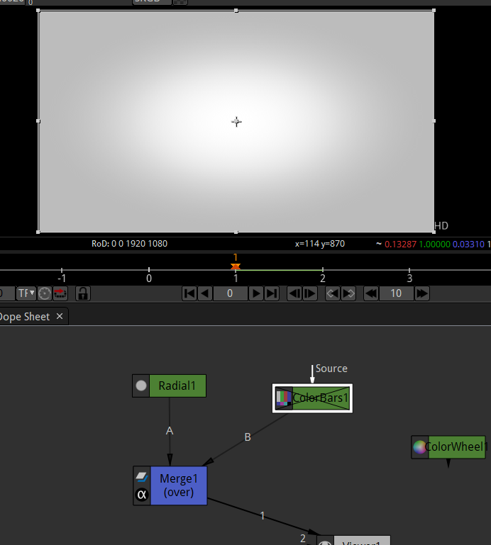

Now we see little bit different we are seeing strong alpha I the middle means 100% pixel in the middle and then lighter one towards the edge

In RGB we can see that we are going to color that is green

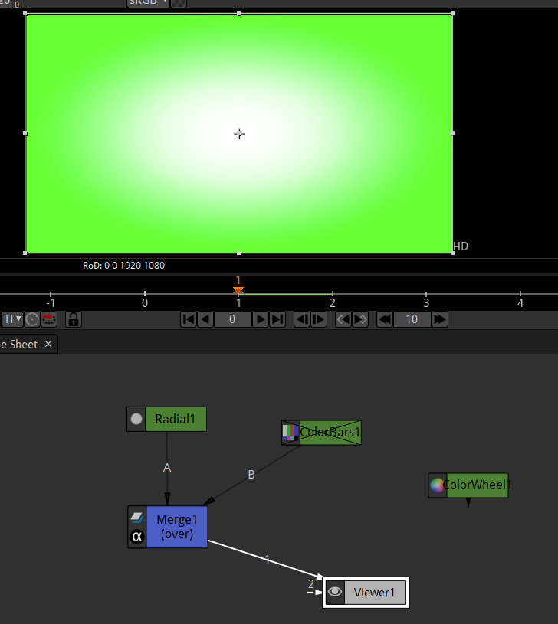

Now we set green to 0.5 in color 0 and then r and b to 0 then we see result below

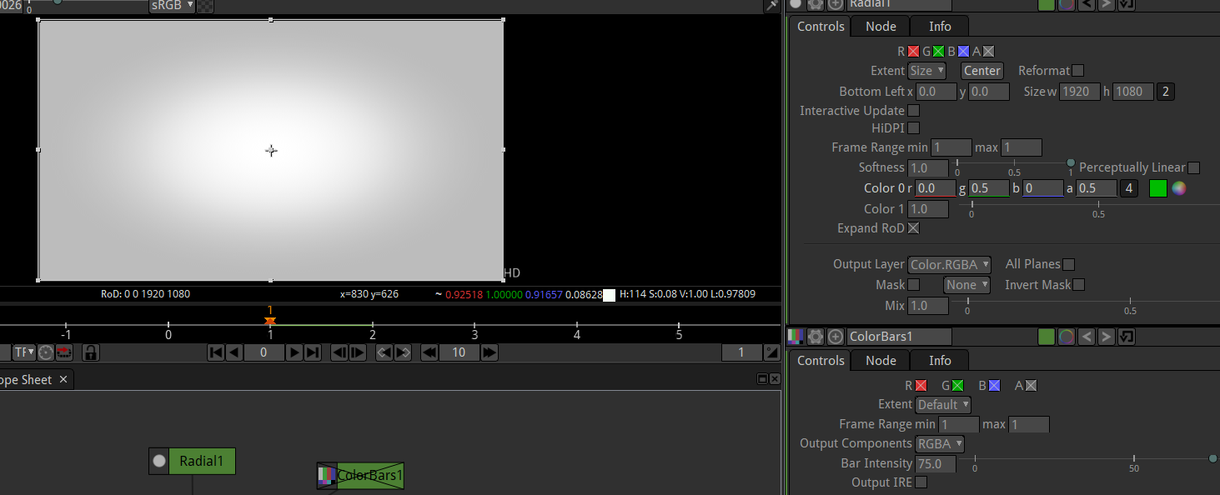

In blue and red I see this

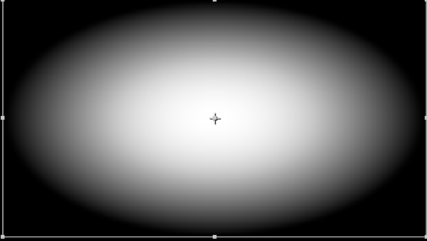

Always remember white consist of all rgb colors

So play around with that

It takes a getting little bit used to but its going to be really really helpful   
If you understand that how this alpha works and id you understrand that the changes you make in the viewer and the way you view alpha here does not always translate to your finished product

9:50

So play with that

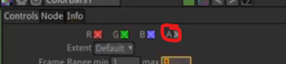

Play with these checking red and greens

Sometimes when you import your image you will have like your alpha channel won’t be on bhy default as marked above

Or if you are just looking at like at

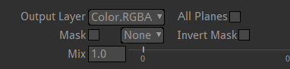

Color output layer and shows Color.RGBA (I think in color bars and similar things to it)

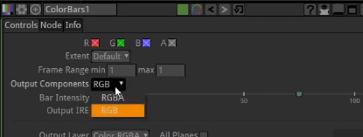(Image)

And sometimes it could be RGB we set it to RGBA

So its important to pay attention to that alpha layer and know how it effects your final output